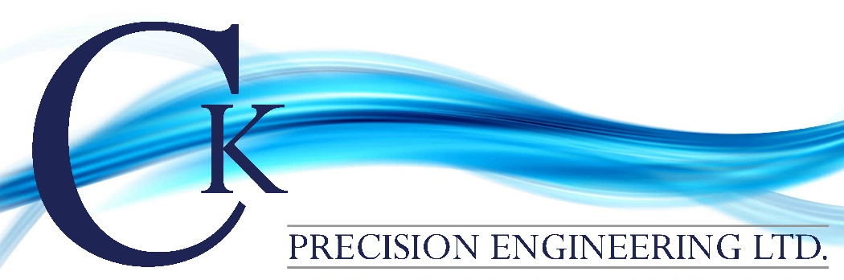

CK PRECISION ENGINEERING LTD

QUALITY PROGRAMME

Quality Policy

The Company Policy is to deliver all products and components, in conformance with client requirements, on time, defect-free and at competitive prices to the customer, so as to ensure customer satisfaction through the provision of quality service and products. To CK Precision Engineering Ltd, quality means that the company meet all order requirements from the moment of receipt of an enquiry to any subsequent delivery of the component or part. CK Precision Engineering Ltd will also address the statutory and regulatory requirements relevant to a product to ensure fitness for purpose. Quality development starts with management motivation and active participation, and management will therefore allocate resources and support the quality improvement efforts of the organisation, giving high priority to informed and motivated personnel.

To achieve these aims, the Company has established and maintains a Quality Management System which conforms to the requirements of ISO 9001:2015 as applicable to the activities of the company. Annually, as a minimum, the effectiveness of the quality programme and the quality objectives of the company will be reviewed to ensure continuing suitability. The quality policy and objectives is communicated and understood throughout CK Precision Engineering Ltd and interested parties.

The Company requires that all personnel work in accordance with the Quality Manual, Procedures, Standards and Work Instructions. All contractual activities are planned, controlled and documented in a systematic manner in accordance with the Quality Plan for each project. Records will be maintained to substantiate the control applied throughout each operation so as to provide evidence of the quality levels achieved.

Keith Wood – Director

Craig Sargent - Director

01/05/2018 K.WATSON

